Page1:

Data source: <https://query1.finance.yahoo.com/v8/finance/chart/>

Data for a single stock company: 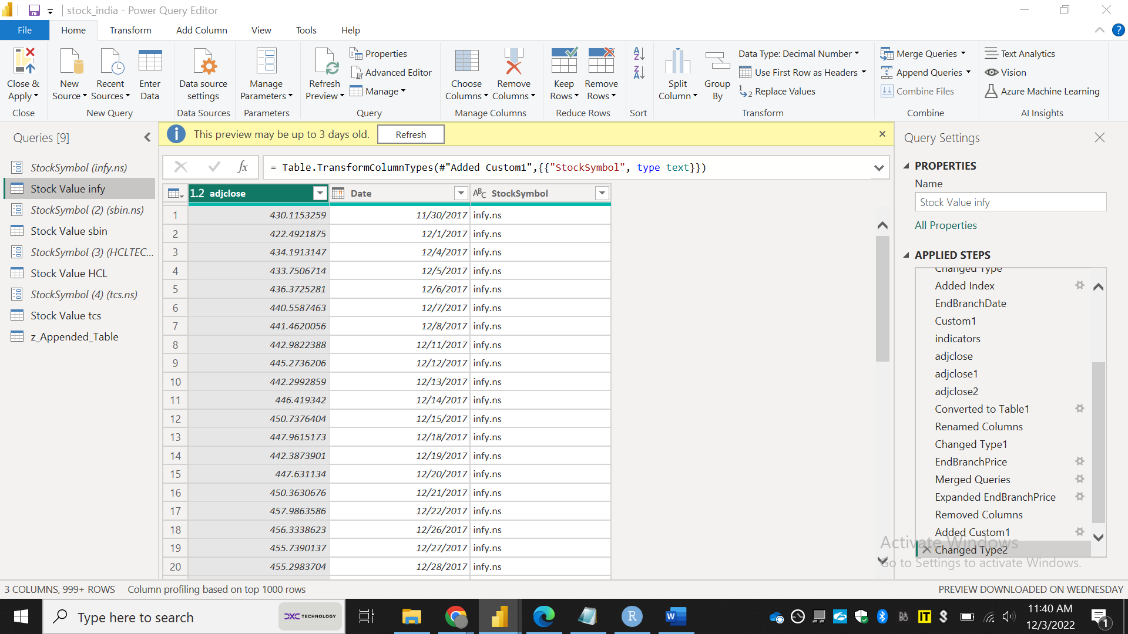

Appended table with all the stocks: 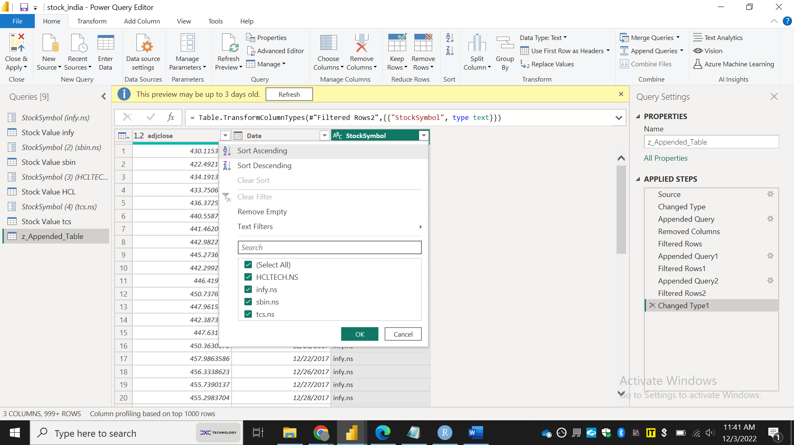

Report page: 